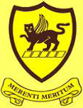
Class Teachers
Dover: Miss Truscott
Farnham: Mrs Brough (Mon-Wed) and Mrs Coton (Thurs-Fri)

Maths
In Term 5, we will be covering decimals, money and time.
In Term 6, we will focus on shape (including angles), statistics, position and direction.

We will continue to practise our times tables daily.
English
In Term 5, we will be writing a newspaper report, with links to our science and geography learning.

In Term 6, we will be writing a narrative and then focusing on performance poetry.
Homework expectations
Spellings: Children should practise their spellings at regular intervals throughout the week. They will be tested on a Friday.

Times tables: Children should be practising for at least 5 minutes every day. TT rockstars is a great resource to support with this. Jamming mode is great for practising a focus times table. Whilst Soundcheck mode is brilliant for those children wanting to increase their speed of recall.

Reading:
In Year 4, we have now had a few children reach 200 reads! This is fantastic.
Just a reminder that in Year 4, we expect the children to be reading daily for at least 15-20 minutes. Whilst the children are allowed to write their reads in their reading records themselves, please ensure an adult is regularly signing it.

Science
In Term 5, we will be looking at animals and their habitats, as well as deforestation. We will also continue with our ‘observation over time’ enquiry. This is where the children explore how seasonal changes influence plant and animal life in our local environment.

After that, we will be learning all about digestive system, teeth and food chains.

Year 4 Newsletter – Term 5 & 6
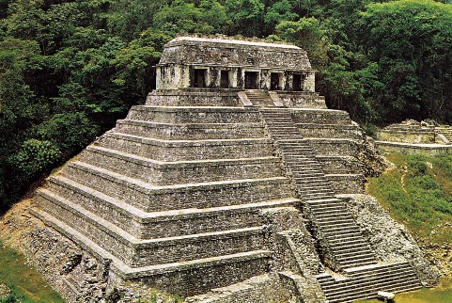
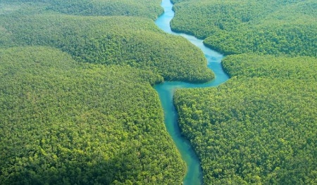

Art
In Term 5, our topic is called ‘Fabric of Nature’. We will be creating artwork which links to our rainforest unit in Geography.
In Term 6, we will be exploring tone, texture and proportion.
Topic (Geography and History)
Our geography learning in Term 5 is all about rainforests.
After May half term, we will be covering a history topic and considering the key question, ‘How did the achievements of the Maya civilisation influence their society and beyond?’
PE
In Term 5 we will be playing cricket. In Term 6, we will focus on athletics, in readiness for Sports Day!
Year 4 Dover will continue with their swimming lessons on Fridays.
RE
Across both terms, we will be learning about Hinduism. Our big questions is: What does it mean to be a Hindu in Britain today?

Computing
In Term 5, our topic is Creating Media, with a focus on photo editing.
In Term 6, we will be programming and looking at repetition in games.
Staff
Dover: Miss Truscott
Farnham: Mrs Brough (Mon-Wed) and Mrs Coton (Thurs-Fri)

Year 4 Newsletter – Term 5 & 6

