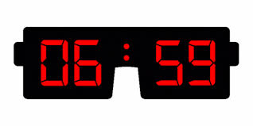

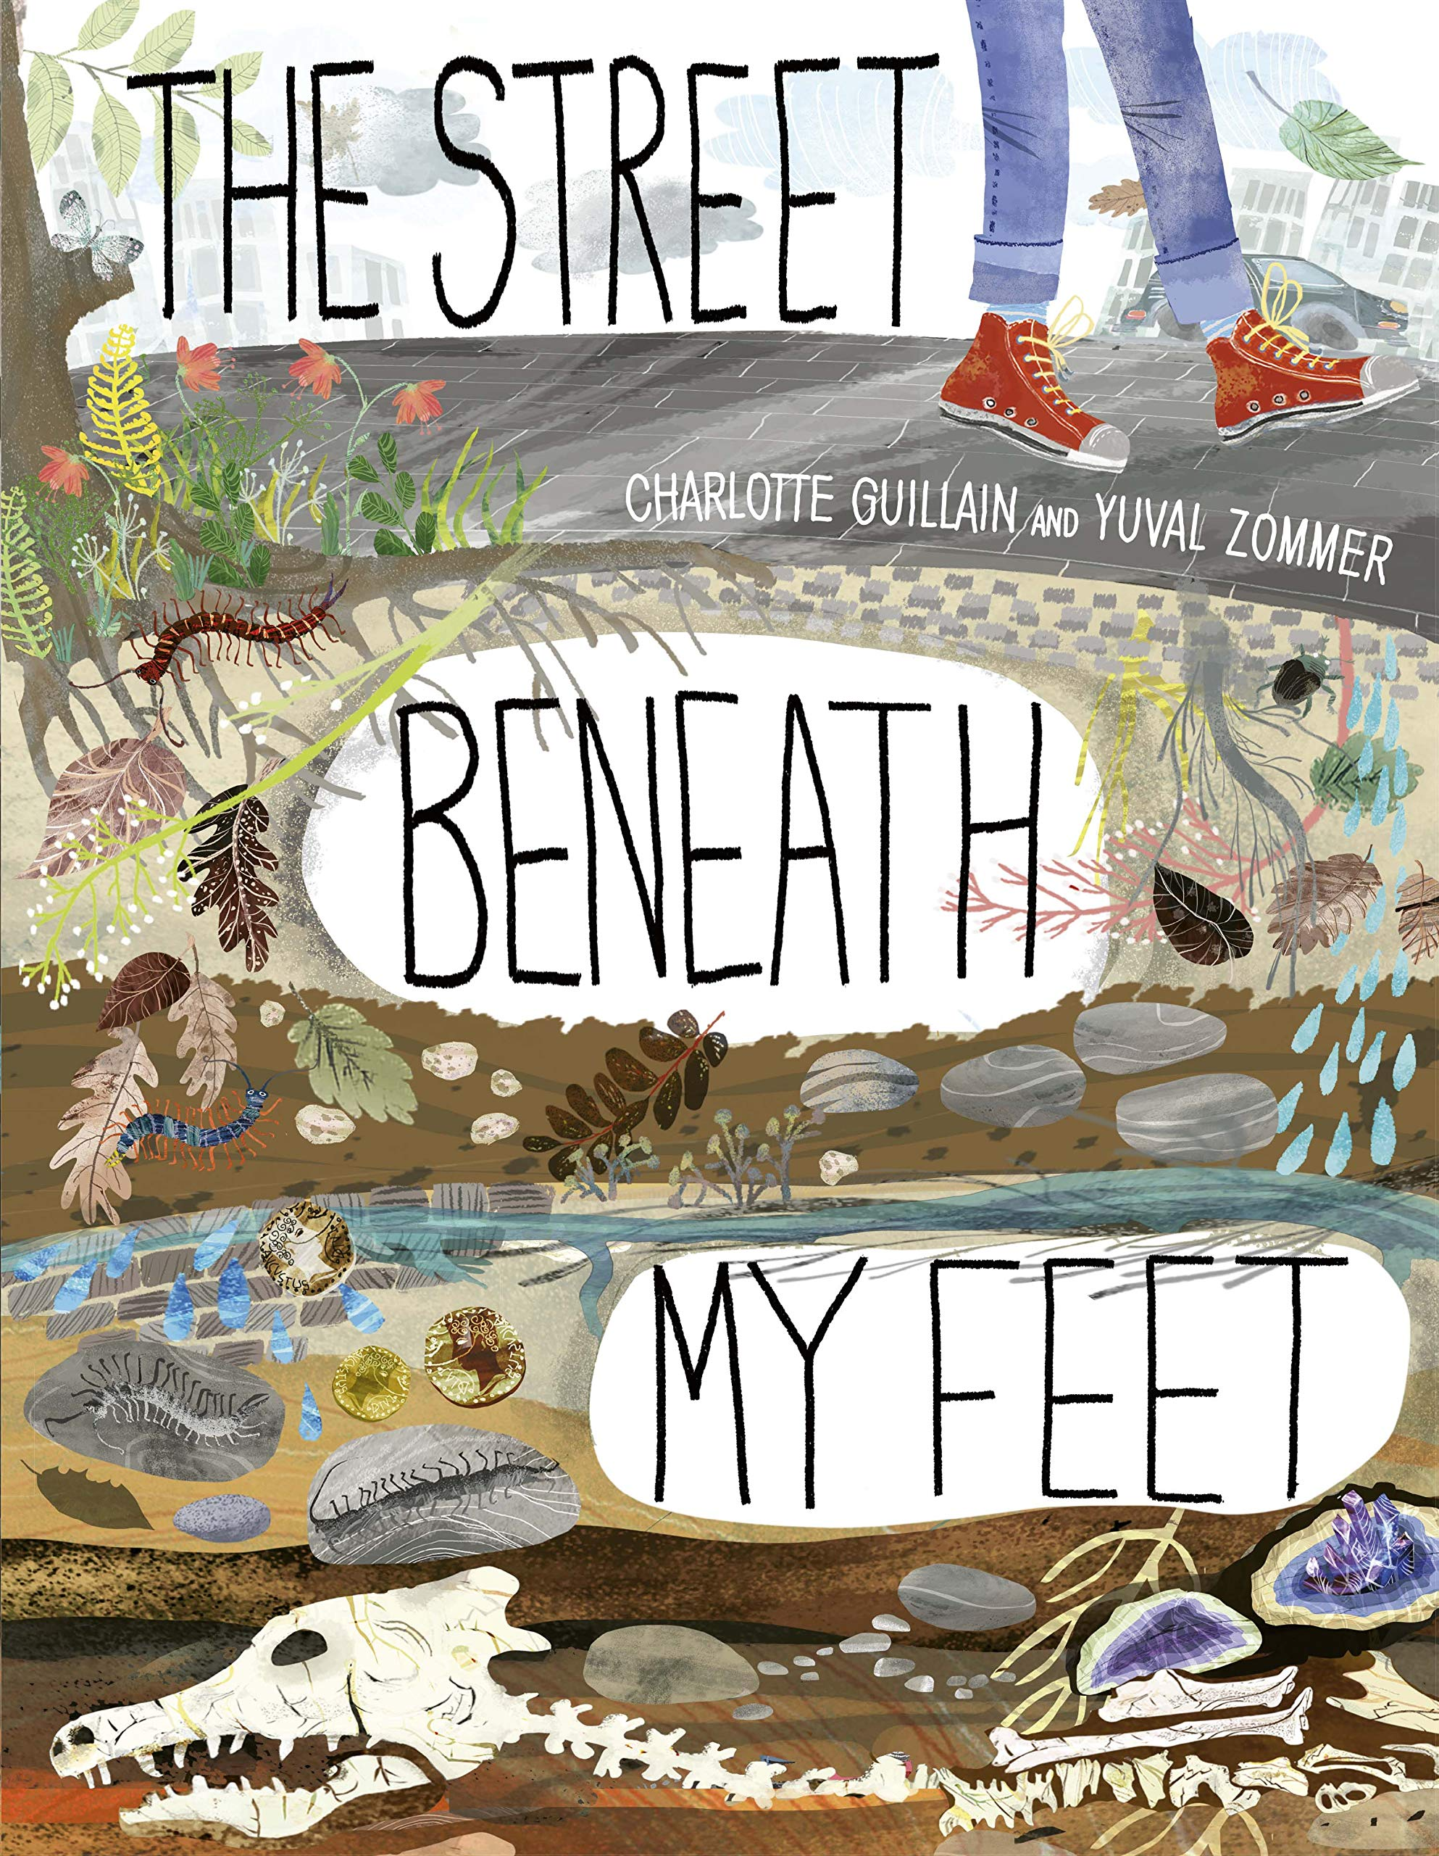
Maths
This term we will be learning how to add and subtract fractions. Following on from this we will be finding out how to convert pounds and pence.
Later in the term we will be learning how to tell the time using both analogue and digital clocks and and measuring angles. Our final maths topic in Year 3 is Statistics and the children will learn how to interpret and draw bar graphs and pictograms.
History
This term we will be exploring the question 'Why did the Romans invade and Settle in Britain?'
RE
We will be exploring the Pentecost and learning about how God's disciples spread the word of God.

Homework
Please read at least 5 times a week with your child for 20 minutes and record their progress in their reading diary. Our Read to Succeed rewards include a book from the cabinet for 100 reads and a tea party with Mrs Crane for 150!
Spellings will continue to be set on a Friday and tested the following Friday.
Teams - please make sure you have your child's emoji login should we need to use this in the future. This can be found on your child's reading diary. To access Teams please use the 'quick link' on the school website.

Science
In Science we will learning how to grow healthy plants. This will include practical scientific investigations to discover the conditions a plants needs to grow well.
ART/DT
This term the children will be learning how to draw using a variety of different mediums, including pencils and charcoal.

STAFFING
Lewes Class Teacher Mrs Majumdar TP Mrs Coleman
Deal Class Teacher Mrs Crane (M-T) Mrs Stevens (W-F) TP Mrs Jenner
PE DAYS
Lewes Tuesday and Friday
Deal Tuesday and Thursday

English
Linking with our history topic we will be reading The Street Beneath our Feet. This a facinating book exploring the journey through the ground to the centre of the earth and all the amazing things we can find. From badger sets to fossils all the way to the Earth's core! The books flips open into one long image - it is it a wonderful text.

Year 3 Newsletter Term 5 and 6

